ST0249   
AI & Machine Learning

Practical 1  
Introduction to AI and Machine Learning



What you will learn / do in this lab

1. Explore AI concepts and applications
2. Explore Machine Learning concepts and applications
3. Explore Deep Learning concepts and applications

TAble of  
Contents

1. Overview 1

Introduction 1

Why AI NOW? 1

2. ARTIFICIAL INTELLIGENCE (AI) 2

AI Applications 2

3. MACHINE LEARNING (ML) 4

Online Demonstrations 4

4. DEEP LEARNING (DL) 6

Online Demonstrations 6

# 1. Overview

In this practical, we would be exploring the concept of AI, Machine Learning (ML) and Deep Learning (DL). We would be looking at some examples of applications that use AI, Machine Learning and Deep Learning.

## Introduction

Artificial intelligence is the simulation of human intelligence processes by machines, especially computer systems. Artificial intelligence (AI) makes it possible for machines to learn from experience, adjust to new inputs and perform human-like tasks.

## Why AI NOW?

There are several reasons for the rapid growth of AI in the recent years

* **Data**: The incredible amounts of data being collected on a daily basis is fueling the development of AI to analyze, find patterns, and provide answers using the data. Facebook revealed that its system processes 2.5 billion pieces of content and 500+ terabytes of data each day (circa 2012).
* **Hardware**: AI requires large amounts of computations to make use of the BigData sources. The availability of large warehouse sized computer centers on demand through cloud computing technologies is enabling AI to tackle problems it could not before. GPU accelerated computing also provides hardware acceleration for the AI servers.
* **Algorithms**: Improvements in algorithms such as Deep Learning and Deep Reinforcement Learning is enabling AI to tackle problems previously thought unsolvable or improving the performance to a level that matches or even surpass human ability. In 2016, Google AlphaGo beat the best human champion at Go. In addition, open source libraries with these advanced algorithms are being released.

# 2. ARTIFICIAL INTELLIGENCE (AI)

In this section we will try out some applications of AI that you can use with your browser (please use Chrome browser).

## AI Applications

**Make Girls Moe**

It's a computer program that helps generate avatars of anime girls.

Use URL <http://make.girls.moe/>

How does it work?

* See <https://makegirlsmoe.github.io/main/2017/08/14/news-english.html> or paper <https://arxiv.org/abs/1708.05509>

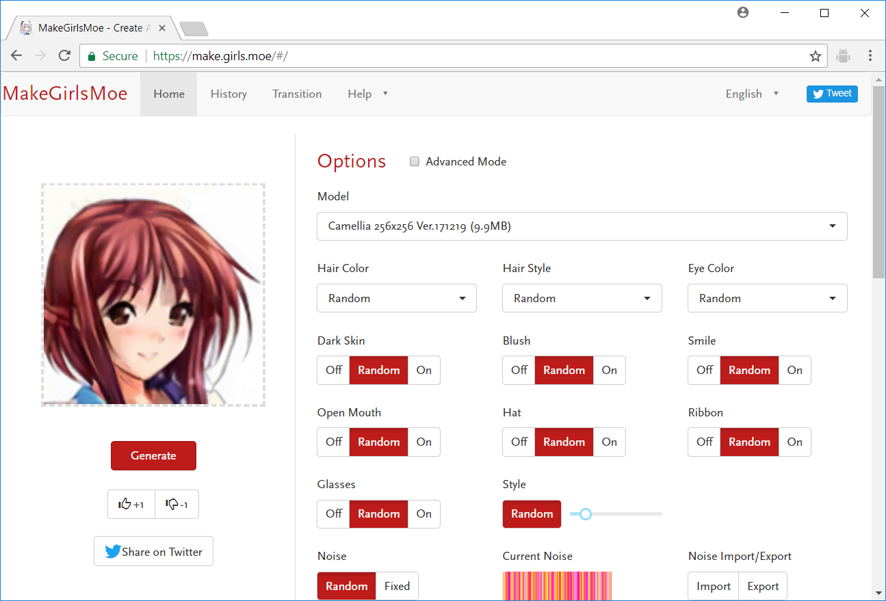

**Activity**

* Take 15 minutes to explore this app.
* Share your favorite avatar

**Cyborg Writer**

It's a experimental text editor with a neural text synthesizer.

Use URL <https://cyborg.tenso.rs/>

For more information on how it works go to <https://www.robinsloan.com/notes/writing-with-the-machine/>

Basically, it uses a type of deep learning network known as Recursive Neural Networks (RNN). The RNN has been pre-trained on examples of sentences by the authors of the different styles.

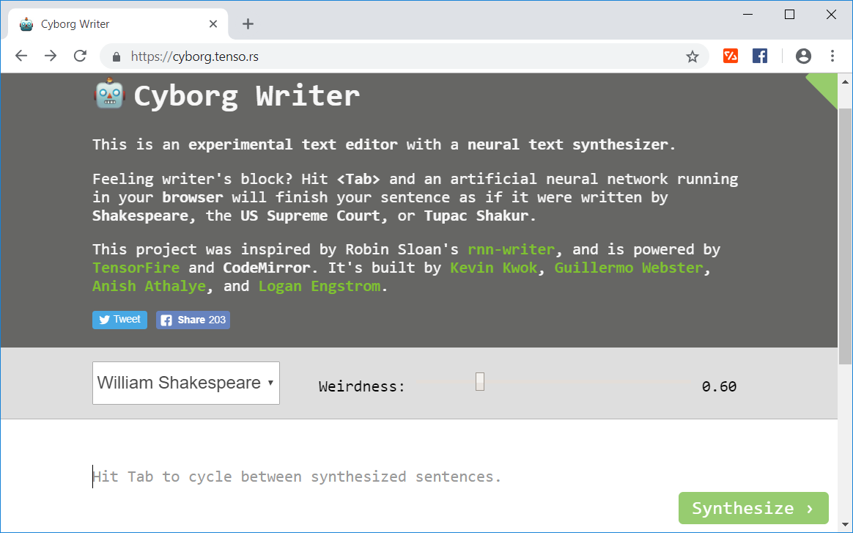

**Activity**

* Take 15 minutes to explore this app.
* Try with a sentence starting with “Make Singapore ….”
* Share your favorite passage

# 3. MACHINE LEARNING (ML)

In this section we will explore a sub-area of AI called machine learning. Machine Learning (ML) is a field that explores algorithms that enable computer programs to improve their performance with time by learning from past experiences with data that is provided to it.

## Online Demonstrations

Demonstrations of machine learning generating rules for generating decision boundaries that separate the different classes of data. Several different algorithms are shown:

* Perceptron
* Artificial Neural Network (ANN)
* Support Vector Machine (SVM)
* K-Nearest Neighbors (KNN)

Use URL <https://peterleong.github.io/ML-Playground/>

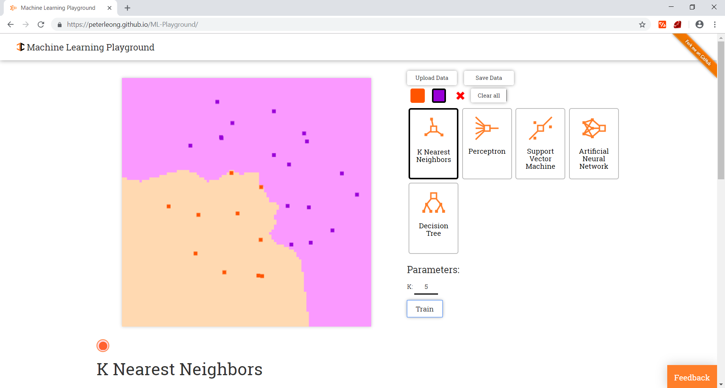

**Activity**

* Take 20 minutes to explore this app.
* Which algorithm(s) work only with linearly separable data?
* What is different between Machine Learning algorithms and normal computer algorithms?
* Observe what happens when the data is unbalanced; when there are many more purple dots compared with orange dots. What are the implications of this on rare events?

Use URL <http://www.r2d3.us/visual-intro-to-machine-learning-part-1/>

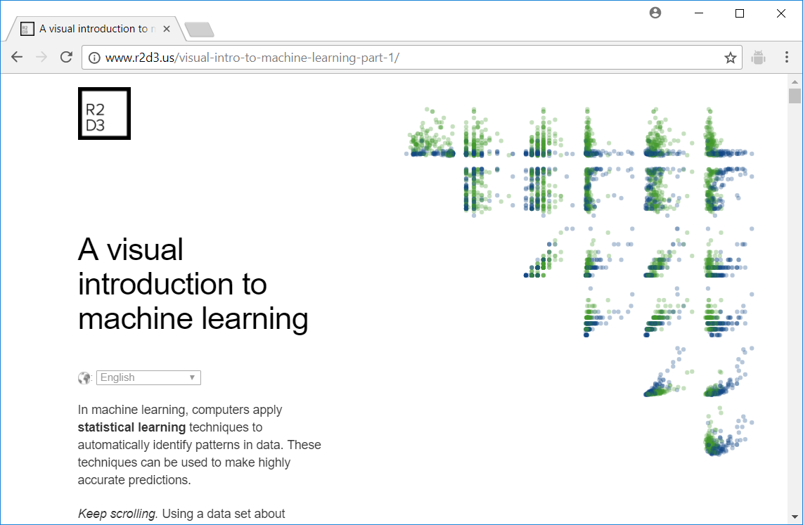

**Activity**

* Take 20 minutes to explore this app.
* What is name of the type of machine learning algorithm demonstrated?

# 4. DEEP LEARNING (DL)

Deep Learning is a sub-area of machine learning. Deep Learning is concerned with algorithms using neural networks with many layers (more than 8). Deep Learning uses learning representations and is characterized by a hierarchy of concepts from general to higher-level abstractions.

## Online Demonstrations

DeepDream is a computer vision program created by Google engineer Alexander Mordvintsev which uses a convolutional neural network to find and enhance patterns in images via algorithmic pareidolia, thus creating a dream-like hallucinogenic appearance in the deliberately over-processed images.

(See <https://research.googleblog.com/2015/06/inceptionism-going-deeper-into-neural.html>)

Use URL <https://deepdreamgenerator.com/>

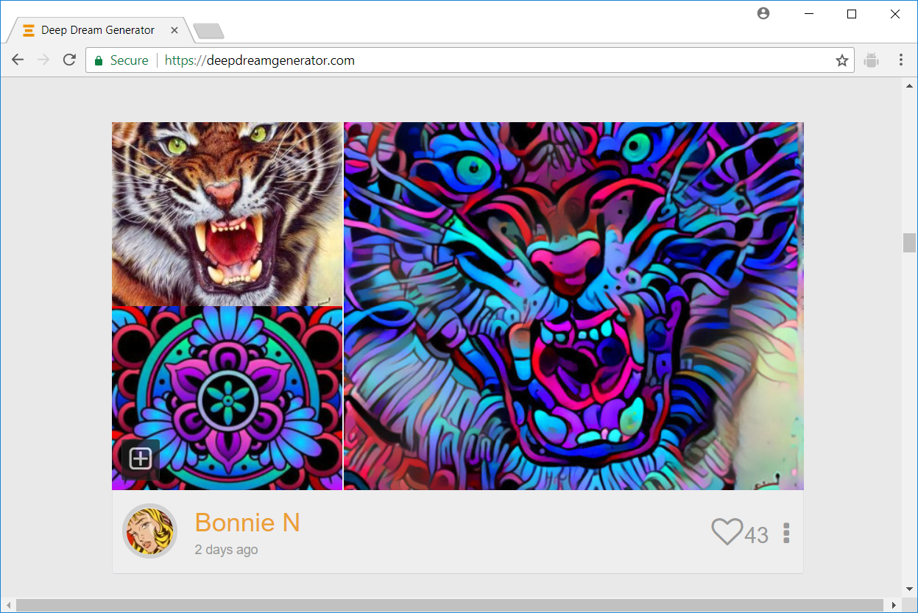

**Activity**

* Take 20 minutes to explore this app.
* What is name of the type of machine learning algorithm demonstrated?
* Share your best creation

**ADDITIONAL EXERCISE**

Try this on your own

Use URL <https://deepai.org/>

**Activity**

* Take 20 minutes to explore this app.
* What are the machine learning algorithms demonstrated?
* Can you identify one that may already be in on your mobile phone?